August 1, 2023

Dear Participant:
RE: Invitation to participate in the Landscapes for Our Future- Global Summit & Knowledge Exchange Event, Nairobi, Kenya, 16th - 20th October 2023
On behalf of CIFOR-ICRAF, the Central Component (CC) of the Landscapes For Our Future (LFF) programme is delighted to invite you to the aforementioned one-week summit.
This event will assemble representatives from all the 22 projects under the EU-supported LFF programme on the campus of The World Agroforestry Center in Nairobi, Kenya. Other landscape experts and practitioners will also attend, along with representatives from EU Delegations and the European Commission.
The summit will:
- Facilitate cross-learning and knowledge exchange amongst implementing partners within the LFF program.
- Offer knowledge and share experiences on implementing landscape approaches across the globe.
- Offer capacity development and technical support to project teams.
- Further strengthen the LFF community and plan for additional CC support to project teams.
This letter serves as an official invitation and for purposes of participant visa application.
Please note that participation to the event is self-funded but the organizers are pleased to help with hotel reservations and airport transfers upon request.
Your presence at this event is greatly appreciated and we very much look forward to welcoming you to Kenya.

Kind Regards,
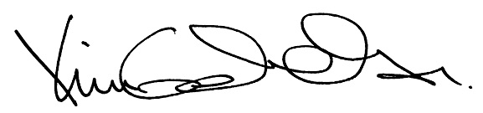
Dr Kim Geheb
CIFOR-ICRAF Senior Scientist
Coordinator, Central Component of the LFF

